Sign Off
Walk-Though | Held On: | Document Version:
Decision | Accept as-is  Revise – no further Walk-Through required  Revise and schedule another Walk-Through

Role | Name of Attendee filling role at Walk-Through | Sign-Off (Content Review and Approval) | Date
Application Analyst
Architect
Business Analyst
Business Lead
Data Analyst
Developer
Development Lead
Development Manager
Division Information Security Officer
Environment Coordinator
Program Manager
Project Manager
Release Manager
Technical Lead

This document has these primary purposes:
- Describe how the impacted Functional Pieces identified in the associated Application Requirements are designed
- Describe the design in such a way that the Analysts, Architects, and Technical Leads can see how the design fulfills the requirements and is consistent with the solution blueprint laid out in the System Architecture Specification
- Communicate the design to downstream project stakeholders so they can start preparing environments for the solution
- Provide the detailed Work Unit Estimates through deploy

There is typically one Application Design Specification for each Application Requirements. See LDM Sizing Guidelines for more information.

Signature indicates receipt of document. Initialing “Content Reviewed & Approved” indicates understanding and acceptance of material.

Please reference LDM Roles on LIDI for details of who uses this document and why.

Revision History
Revision # | Date | Description | Author
1.1
1.0
[Note to Author:
The Revision History is maintained once the document is signed off. Prior to signoff, changes to the document do not need to be tracked here, however, any changes to the document require a new version to be saved. Place most current version first. The list is in descending order.]

Table of Contents
Sign Off 1
Revision History 3
Table of Contents 3
Design Goals & Guidelines 4
Application Design 5
User Interaction Design 5
User Interface 5
Reports 5
Forms & Correspondence 5
Application Component(s) Design 6
Component A (Program XYX) 6
Component B (Program XYZ) 6
Component C (Program UVW) 6
System / Application Interaction Design 7
Internal Data Management 8
Logical Database 8
Physical Database 8
Files & Tables 8
Initialization & Configuration 8
Security 9
Auditing 9
Physical Architecture (Physical Infrastructure) 9
Diagram 9
Description 9
Initial Data Load & Conversions 9
Operational Management 10
Defined Work Units & Estimates 11
Development Test Cases 11

Design Goals & Guidelines

[Note to Author:
Describe any goals, guidelines, principles, or priorities that dominate or influence the design. Examples: Keeping the design simple (KISS principle), emphasis on speed, consistent “ look and feel” with existing application(s), etc.. Describe the reason for each goal or guidelines importance. The associated System Architecture Specification should be consulted for overall Architectural Goals and Guidelines.]

Application Design
[Note To Author: This section describes how the specific Application components are designed. There are three sections, which parallel the sections in the Application Architecture Diagram from the Application Requirements
- User Interaction
- Application & Component
- System Interface]

User Interaction Design
[Note To Author: This section describes the design of the User Interaction. It is divided into three sections:
- User Interface
- Reports
- Forms & Correspondence
If there are additional User Interaction pieces not covered, add the appropriate section. Note: this entire section will be “ lifted” for creation of the User Design presentation.
Screen shots or other prototyping in an application may be used to clarify interaction design.]

User Interface
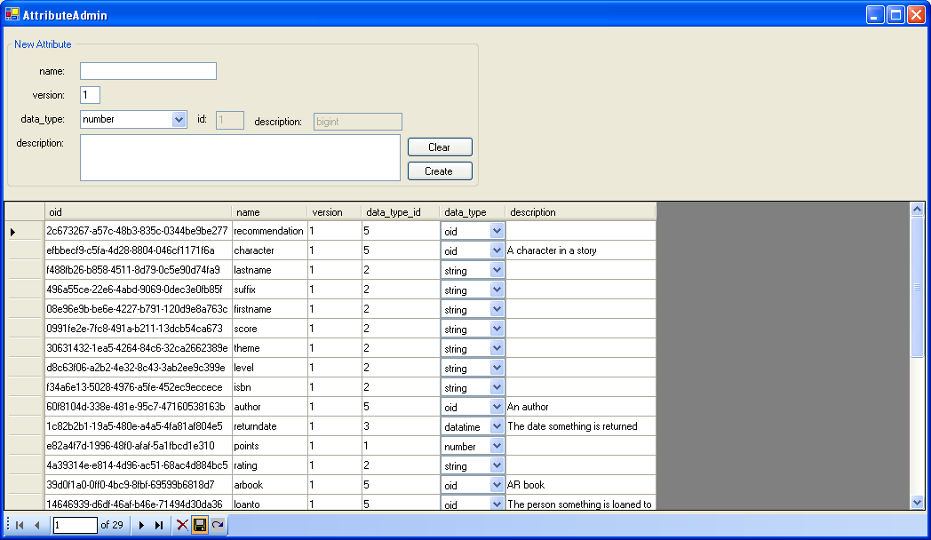
[Note To Author: Describe how each User Interface is designed, including screen layout and flows. Insert actual screen shots of designed UI component if you have them; otherwise include mockup(s).

Reports

[Note To Author: For each report that must be produced, write up a brief summary describing how the design addresses the requirements from the SR document. Attach actual report layouts if you have them available; otherwise insert a mockup.

Forms & Correspondence

[Note To Author: This section documents the design of all modified or new forms and correspondence used in the application. (e.g., policy pages, document types, standard PL letterhead, etc.). Place an example of the proposed document here.}

Application Component(s) Design

Component A (Program XYX)

Component B (Program XYZ)

Component C (Program UVW)
[Note To Author:
In this section the changes to the components outlined in the Application Architecture diagram in the Application Requirements are described. A brief functional statement for each component and the impact of the change will be provided. Describe the primary responsibilities and/or behavior of the component including interactions with other components. In addition all input, output and processing enhancements are described.
Sections should be broken out by area of processing within the system where appropriate. For example, you might have sections for Online Processing, Batch Processing and Report Processing, OR you could arrange sections by application functionality, such as Accounting, Policy Processing, Claims Adjusting, etc. Providing some type of sub-sectioning here will allow for easy recognition of what the impacts are on each area of processing within the application. Additional sections for modifications may include Operational / Technical overviews, such as RELINKS, JCL, PROCS, DATA, CTC, and CT2 impacts.
Important Note: Do not go into too detailed a level here UNLESS you have System Interface changes in your design. It is important to gain agreement on System Interface details during the Design stage with other applications!
If you do not have System Interfaces, keep your component descriptions at a high-level. The initial section of the Build stage will be used to outline detailed descriptions such as Class description for Wintel applications, etc.
Describe and configuration that must be done to 3rd party packaged applications.]

System / Application Interaction Design

[Note To Author:
For each external interaction, describe the details of the interface. Representatives of each interfacing application should agree to this “handshake” information during this stage. Include the following, if applicable to the application(s):
- What and how (e.g.; One file, fixed length records.)
- External items - received or returned
- Source System / Target System
- Interface trigger events
- Data Entities
- Type – Automated, Sync, Async
- Business Class Name / Attribute
- Group Name
- Transformation required
- Validation expected
- Length/Nullable
- Description of Mapping]

Internal Data Management
[Note To Author:
This section describes the data management needs of your application. This section is not used for external system interaction]

Logical Database

[Note To Author:
Describe at a high level the logical data model changes that will be required. What are the new, required, data elements. Describe any application internal conversion logic necessary to accept or deliver data to the external sources. Insert an Erwin-generated data model here, or reference the generated data model if it’s too large to include. This model should be based on the Data Elements from the System Requirements.]

Physical Database

Stored Procedure Naming Convention:
up_<table>_<operation>
e.g. up_tbl_attributes_select_all

Diagram

[Note To Author:
Describe the physical database structure(s) here. Include table names and fields. Indicate if database stored procedures will be used.]

Files & Tables

[Note To Author:
This section documents file changes that will be necessary to implement this modification. This includes new fields on the Policy Master record, and/or reference files such as the PDF. Include type of file (i.e.; VSAM) field name, size, segment placement and if applicable Reference File Card location for input.}

Initialization & Configuration

[Note to Author:
Describe the initialization and configuration design of the application. Include appropriate descriptions for the following, if applicable:
- How the component will be packaged for deployment (e.g.; DLL, ASP page, etc.)
- If registry keys are required
- Initialization and Configuration Settings
- Machine / Web / Application configuration files]

Security

[Note to Author: Describe at a high level how authentication and authorization is performed. Describe the Pacific Life Security Policies that apply and how the standards are met. Make sure you meet security requirements outlined in the AR and have described how Data Classification has been addressed in the design.]

Auditing

[Note to Author: Describe how the auditing requirements will be met.]

Physical Architecture (Physical Infrastructure)
[Note To Author:
This section consisting of a picture (Diagram) and text (Description) shows how the logical pieces of the system / application are deployed on physical things (servers, workstations, mainframes, and other hardware) and in which security zone those physical things are located, and what ports and protocols are used in the communication.
Show where the following things are deployed:
- Executables and DLLs
- Databases
- Web Pages
- Other components]

Diagram

[Note To Author:
Insert a diagram of the physical view of the infrastructure. Have a preferred set of shapes to show servers, cpu’s, security zones, ports and protocols as appropriate.]

Description

[Note To Author:
Describe the diagram above with relevant details (e.g, where are servers in which DMZs, Port Requirements, regions where databases or transactional applications will reside, etc.]

Initial Data Load & Conversions

[Note To Author: If applicable, describe the first-time load and conversion required to go to production. This section documents details regarding the possibility of file, database or business rule conversions associated with the requirements. Include reporting and testing requirements for these initial loads and conversions to ensure they are accurate prior to installation.

Operational Management

[Note to Author:
Define high level any operational impacts to the network and mainframe topology. This is includes software upgrades, new software components, hardware requirements, network routing and bandwidth changes and overall user and system security changes. Consider all environments; development, testing, staging and production when making this assessment. Describe production support needs, e.g. Audit, archive, re-org, shrink, backup.
Database: Audit, archive, re-org, shrink, backup
File & Tables: Audit, archive
Application: Cycle, refresh, restart.
JCL
Job Flow and Job Dependencies
CA7 stuff
Retention Management]

Defined Work Units & Estimates
[Note To Author: Based on the gathered Application Requirements and Application Design, break the expected work into chunks and provide estimates
Include work that needs to be done by 3rd party vendors, e.g. configuration and changes to a packaged solution.]]

Work Unit | Estimate (Man Hours)

Development Test Cases
[Note To Author: Describe test conditions and expected results for the development testing effort. Be sure to include functional test conditions related to changes made as well as negative test conditions Specify data required to conduct test]
Test Condition | Expected Results | Data required

Design
For thing
Get all properties
For each property
Get all Properties

Do we allow this to recurse?

How to handle connection strings.
Global - .bas file
Module .cls file

Since construct string in COM+ is per class, seems like could have separate DB for each class. That suggests global variable would be problem for single program using multiple classes. Need to test this.

Explore how to see number of DB connections and other overhead.

Implementation
Database
Each table has associated Class to do basic I/O (select, insert, update, delete). All database classes implemented in one DLL, VNCDB.dll. Test Harness project provides simple form to test basic functionality.

ToDo
Add transaction abort for testing.
Work on presentation layer.

Issues
How do you create new database objects?
What are method names?
For example, say you want to create a new Person. You can New the object. When does it get an ID in the database?
ToDo:
Write Stored procedures for tbl_usage_attributes and tbl_data_tables
Is ARBook in the right place? Perhaps it should be on Book and not Story
Is ISBN in the right place? Does it every change with reprinting?

XML
How to reference external schema, e.g. person.xml in book.xml for author, loaned to, etc.
Get Vikki to create sample XML books using Book.xml template.

